|  |  |  |
| --- | --- | --- |
| Wiki Lix | What are you looking for……………………………………………………………… | **search** |

|  |  |  |  |  |  |  |  |  |
| --- | --- | --- | --- | --- | --- | --- | --- | --- |
|  | Home | About us | Services | Buy products | For rent | properties | news | Contact us |
| Home: WIKILIX.COM  C:\Users\AFM BUSINESS GROUP\Documents\Rwanda-kigali-cleanest-city.jpg  About us:  Mission &Vision:  Membership:  History:  **Service:** * shipping and delivery  *Procurement consultancy  **Buy products:** posting manufacture’s products on our portal and pay fees    **For rent**:* living rooms  *lodge rooms  *apartment rooms  *trading houses  **Properties: \***houses on sale  *land on sale  *used equipment  **RWANDA D.R.CONGO TANZANIA KENYA BURUNDI GABON UGANDA** | | | | | | | | |

**Shipping and delivery:**

We are the one leading global shipping and delivering of the products abroad to customers worldwide.

**OCEAN AND SEAS FREIGHT**



****We facilitate the importers and exporters in delivery and transported products from abroad. We have storage solution for you

Transported products from abroad. We have storage solution for you

**AIR FREIGHT**

****We facilitate the importers and exporters of various products from different countries

We have storage solution for you

**LAND FREIGHT**

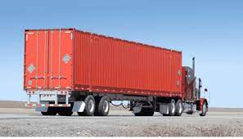 We offer land transport and distribution services across the world.

**Ware housing and customs services:**

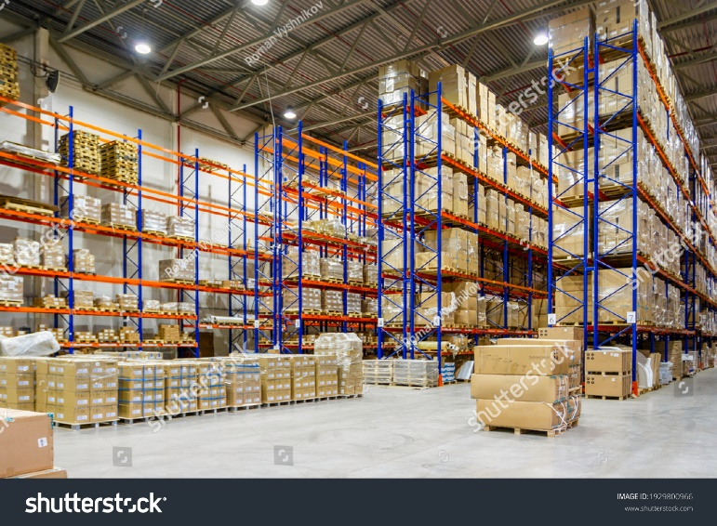Trade Services rely on extensive experience in facilitating trade, to develop and deliver new Total Quality Assured services for governments, customs, authorities and standards organizations

**Procurement consultancy services**

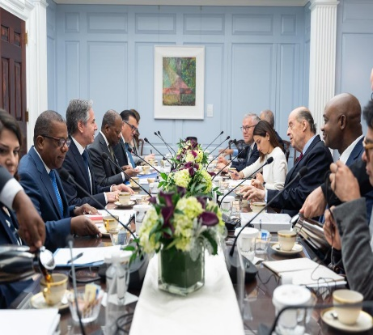We are professional specialists in procurement where we help our clients to empower organization with strategic procurement solutions, fostering efficiency, sustainability and profitability while maintaining ethical and transparency practices.

We offer different services including,

Procurement process optimization, evaluation, suppliers’ selections, contract execution and contract management.



Supporting suppliers/bidders to study, and analysis global tenders and we connect with eligible suppliers.

We provide coaching and training to bidders and newborn bidders that enable them to have capacity for competing on existing projects.

**For Rents services**

**Living rooms:**

**On rent: Kigali - Gikondo $99 / 1,000frw**

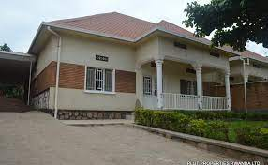

View details: no of rooms & bath rooms etc.

On rent KIGALI- REMERA $300/300,000FRW

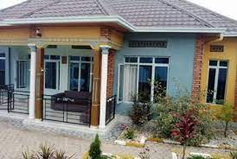  
 **View details**

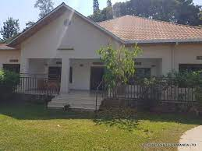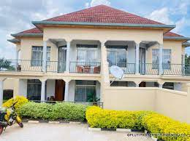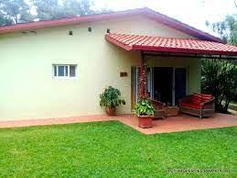

View details

**Lodge rooms:**

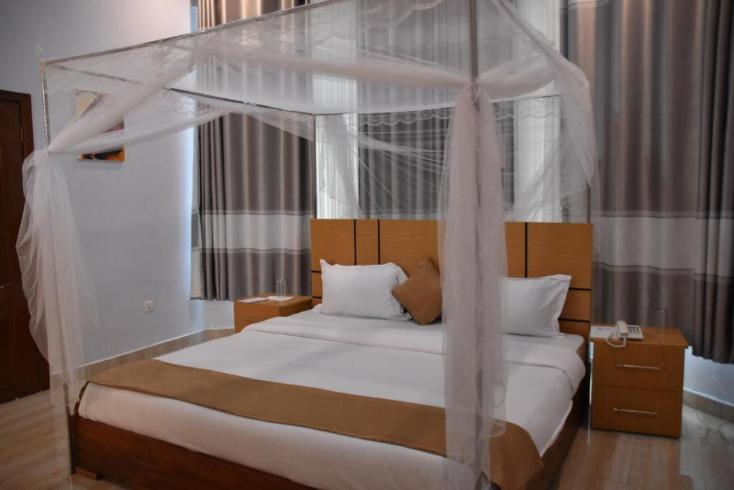Available rooms: Kigali- NYAMIRAMBO $10/ 10,000FRW

View details: one night is 10,000frw with dinner and breakfast.

**Apartment’s rooms:**

On rent KIGALI – KACYIRU $1500/15,000,000FRW

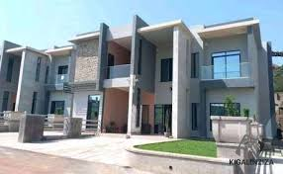

**View details:** three rooms, sitting room, dining room, 2 bath rooms, jaride etc.

**Trading houses:**

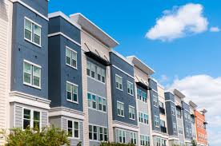



**Buy products**

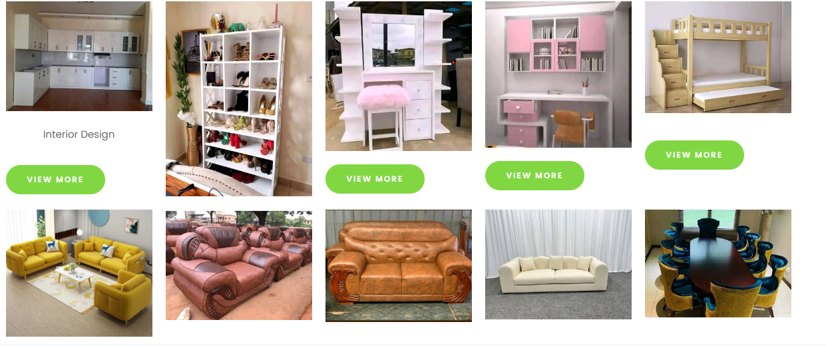

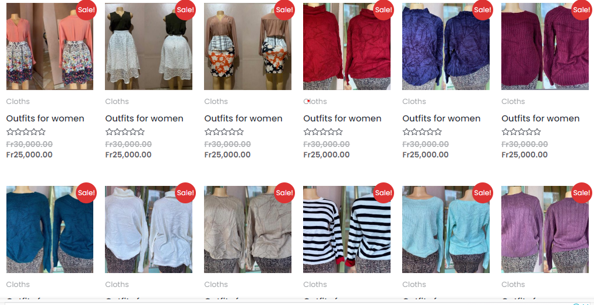

**News:** announcements

Events

Testimonies

Contact us,

Address: Kigali- Gikondo

Tell tsap: 0790704933

E.mail:info@crprogram.wikilix.com

Instagram: WikiLix

Facebook:page: WikiLix

Twitter:WikiLix

**MISSION:** our mission is a quickly connecting and linkingthe people who are searching services with other people who are providing the services globally.

**VISSION:** Our vision is to become the leading online quick services access platform worldwide, by innovating the way people search rental properties, buying and selling products, consulting and shipping cargos across the World.

**HISTORY:**

WIKILIX.COM is a platform or a portal has designed and developed to facilitate communities to get access on some services like rental properties, trade transactions mainly for used equipment. This has initiated in order to solve time waste and anxiety for looking and waiting services.

Most of the people they change living locations due to different factors so, by this to make sure for getting where they will get rents its become a big issue to deal with, that is why WIKILIX has brought a solution for this problem where people from worldwide should visit this portal to search better rent that is comfortable for them. Not only rents but also always we need some equipment like bedrooms equipment, kitchen equipment, home equipment and others. and it is not always we got ability to buy new, occasionally we need used equipment or secondhand equipment. This is a portal that will enable persons with that equipment to post and enable those persons that is need them to get it easily and quickly.